Experiment: 6
Simulation and BER Analysis of MIMO and Beamforming
OBJECTIVES:
• To simulate a basic SISO and MIMO wireless link.
• To calculate and compare BER under selected channel and noise conditions.
• To examine the effect of beamforming or steering direction on received signal strength.
• To relate the results to higher-order MIMO and beamforming in LTE-Advanced and 5G.
PROGRAME CODE:
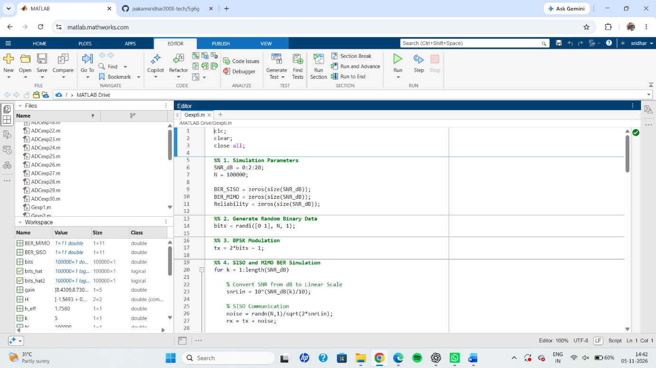
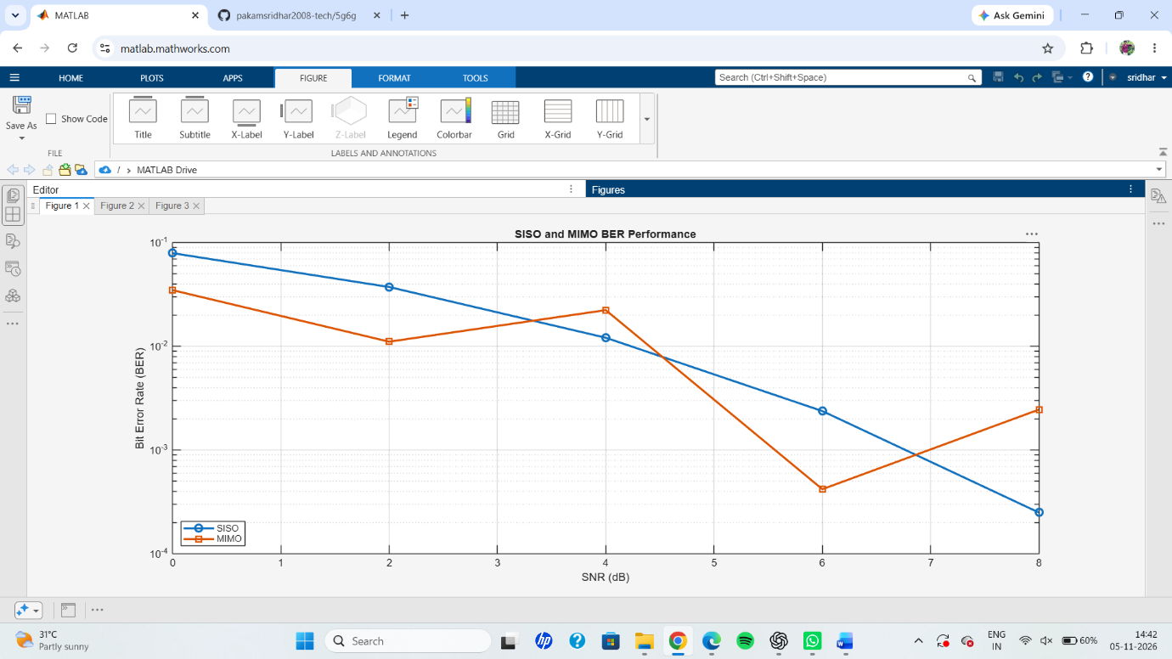
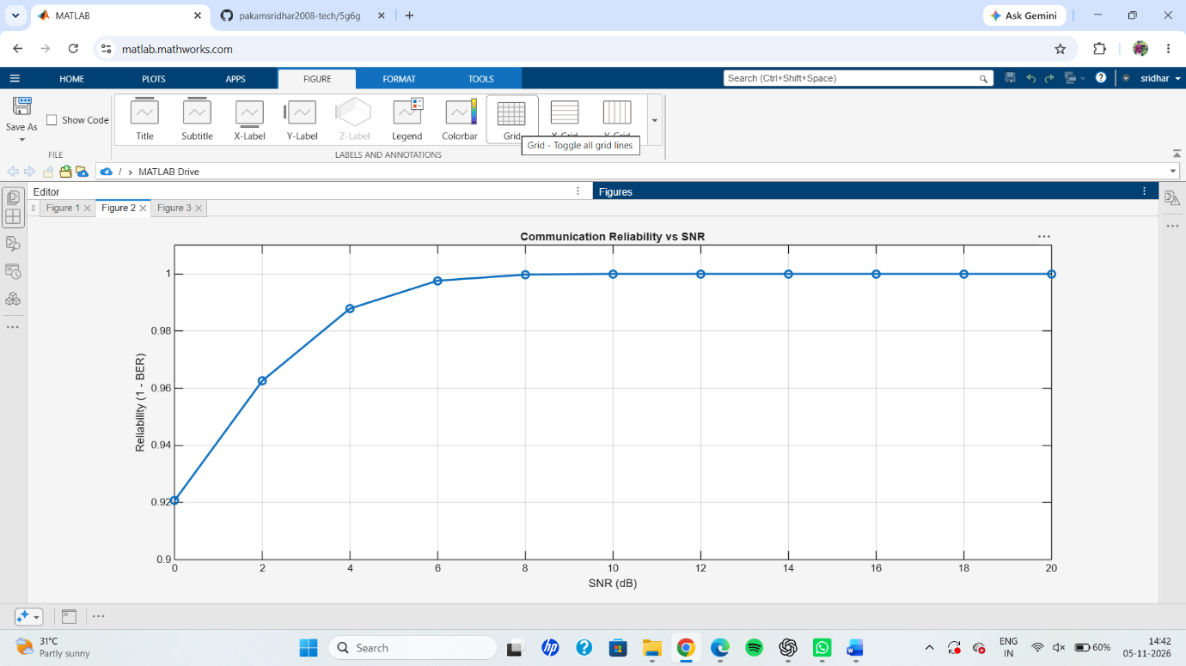
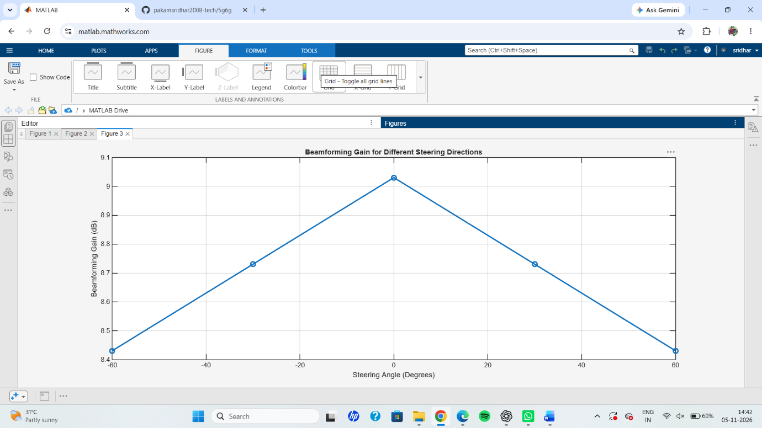
RESULT: Thus, the MATLAB simulation of SISO and MIMO communication systems, communication reliability, and beamforming performance was successfully carried out. The results demonstrate that BER decreases and communication reliability increases with increasing SNR, while beamforming gain varies with the steering direction.

